DCCN – LAB-3
Name: Poojith Kumar Roll N.O: 124cs0029
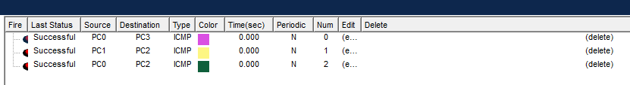
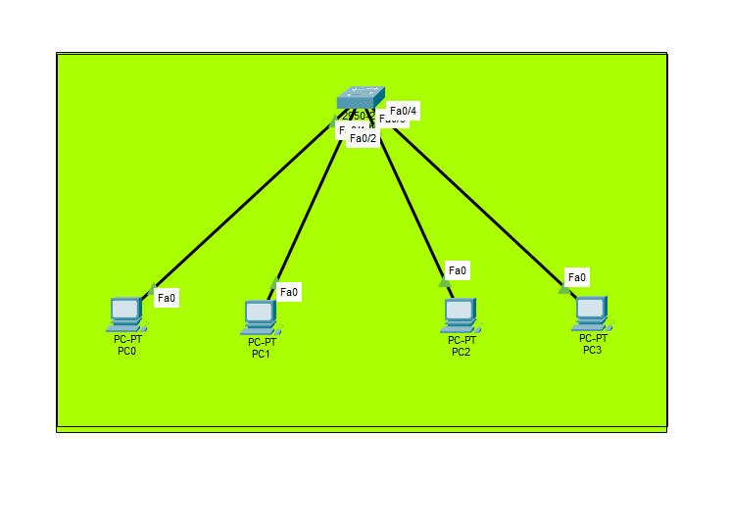
1)

2.
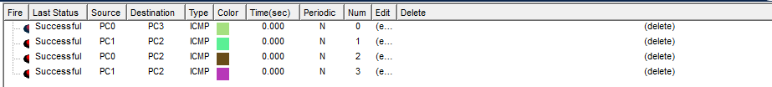
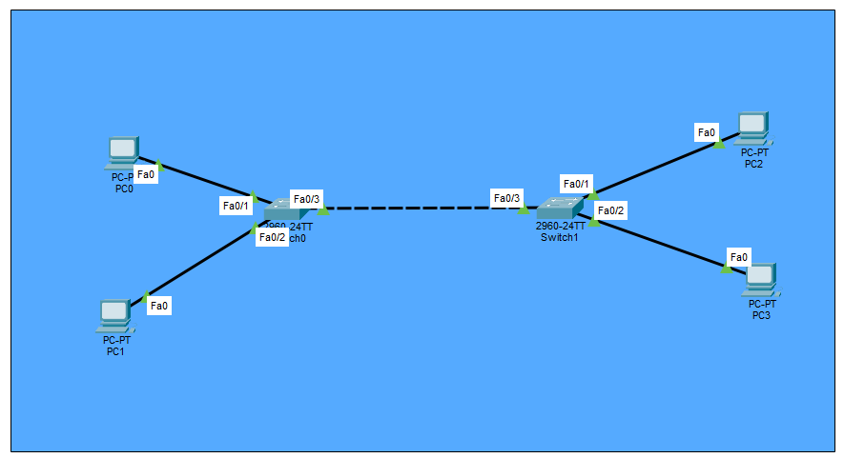
3.
